**Engineering Notebook**

**Team 16 – Clear Path**

By: **Isaac Hewitt**, Cannon Newbury, Sadeed Khan and Michael Yun

**09/12/2024** - Team 16s first meeting and talk with customer, Dr. Towhidnejad. Scrumwise and Github established to start adding to backlog and documentation for the project. Division of skills between team members like Scrum-Master, Software, Hardware, and documentation. Stand up meeting to discuss the proposed objectives from customer and first steps taken.

**09/24/2024** - Teams first day in LB 131 with the flight simulator. Below is some of the information we gathered.

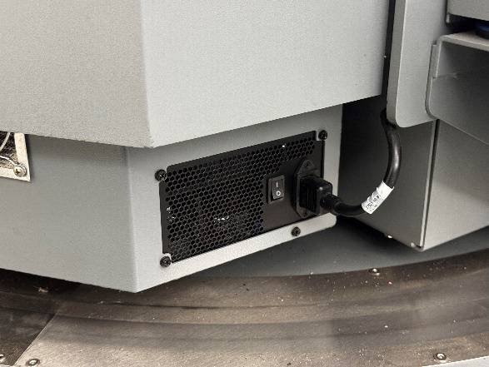

The white switch turns on the whole rig, and the smaller switch on the right side is now to turn the PC on.

There is a small red button below the seat on the right side, click the button one time for the green light to illuminate. Finally plug a wired keyboard into the hub on the right picture, follow the prompts on the screen and get to the home screen. From there we can use the wireless keyboard with mouse built in to navigate. We also uploaded any relevant text documents into our GitHub (<https://github.com/SadeedKhan555/ClearPath>).

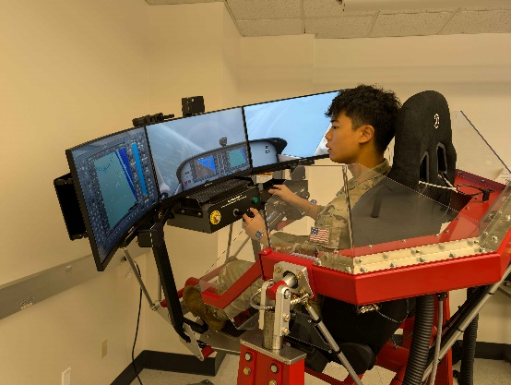

We got some time in on the simulator to see the different function, and displays within X-Plane.

10/15/2024 - Replacing Emergency stop button, part was ordered a week in advance install was slowed due to hurricane and campus closure. Images for button install are below. In addition, the peer reviews were completed by team members along with the sprint review presentation.

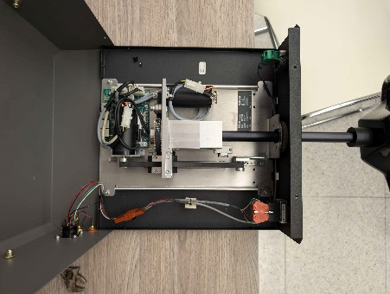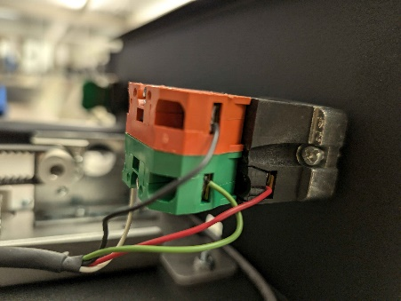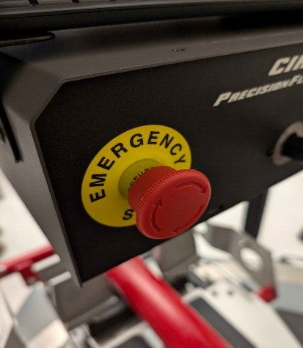

10/22/2024 - United Briefing; No work done

10/24/24 – Team meeting with student previously in charge of flight sim to ask questions related to start-up and uploading/inserting data into Xplane. Installation of graphics drivers to flight sim computer to start running XPlane 12. Sprint 3 finished; Items on backlog rearranged to reflect future project progress. Also began linking some minor accounts together to make upkeep of the sim easier.

* Sprint obectived accomplished:
  + Meeting with student in charge of sim

10/31/2024 - We also started working on our presentation. We also started working on finding APIs to implement into xPlane, but Flight

11/7/2024 – This week I worked with setting up the APIs that we had decided to work with into xPlane, we found that FlightRadar24 might not be the best choice, but there are other options.

11/14/2024 – Peer eval earlier this week. Working on getting APIs implemented this week. ADSB.fi might be our best option.

11/21/2024 – Work on the SRS, SDD and other documentation. More work on Simulator throughout the week, having a hard time getting it to read data being pulled.

11/26/2024 – Documentation day – lots of it. Got the simulator to read ADSB flight data earlier this morning, which was key to getting live traffic implemented. Ended up needing some extra executable that I feel should have come pre installed on Windows due to it being C based, but I guess not.

12/05/2024 – 10-minute video was recorded earlier this week. We presented our project in the COE and worked on any documentation that still needed to be completed. Might need extension for the test plan.

01/14/2025 – Found a program called OverlayEditor that allows editing the map scenery in Xplane, allowing us to place planes and cars and even boats, could be useful but we still need to find a way to make the things we spawn in move.

01/16/2025 – Plugin research, found some options to help us with incurrsions.

01/21/2025 – Met with French Air Force Academy Interns, very well versed in sim knowledge and have some coding experience to help us and vice-versa. Thomas and Mathilde

01/23/2025 – Found FlyWithLua, allows for scripting your plane and supposedly extra aircraft with a language called Lua. Working on making scripts

01/28/2025 – Found RAAS, a plugin that tells you about your location in gamespace, like if you are on the runway, a taxiway, if you are taking off too fast, if you are at too high of an altitude to land and more.

01/30/2025 – Finally got to doing my Engineering Notebook, and did some more stuff with Lua scripting.